Oliver Collins-Cope

2102775@rutc.ac.uk

Learning Aim B & C

Design 2D and 3D digital graphics products to meet  
a client brief & Develop 2D and 3D digital graphics products to meet a  
client brief.

Unit 17 2d And 3D graphics

Assignment 2

Contents

Introduction 2

Design 2

2D Design 4

3D Design 5

Assets used 5

Design justification 6

Evaluation 6

Feedback 7

Changes made based on feedback 14

Developing graphics 14

2D Graphic 14

2D Optimisation 14

3D Graphic 14

3D Optimisation 14

Evaluation of Graphics 14

2D Evaluation against brief 14

3D Evaluation against brief 14

# Introduction

# Design

Throughout this section I will document the design of the overall graphic and also display the specific section for the 2D Graphic and 3D Graphic.

This displays the overall beginning of the design, ranging from the drinks name to the graphic requirements, such as 1920x1080 image. This helps to outline the direction that my drink should take in order to be successful from the client brief.

Here is the Moodboard that includes information about the design choices made here in order to ensure that the drink is successful once it is made and launched.

The text is included below:

“I am designing my can in this way to ensure that it draws attention. Bright vibrant colours that pop out at the consumers will help to ensure that people see this can. A hand drawn design for the can title and the advert slogan means that the text will be unique and another selling point for the can. Finally, the themes for this can promote the target audience, pushing the idea that this is a drink for those who play games and want energy, as well as the E-“Style” scene which has been very trendy recently. Vibrance is important as it allows the drink to promote itself simply by existing, and the edginess factor is something that can be modified depending on the results of it. I.e., including or not including specific graphics.”

## 2D Design

This is the initial design for the can that will be used. This is to be displayed the can and will contain all the nutritional information, while maintaining the colour and vibrant theme of the drink.

## 3D Design

This is the initial 3D design made inside of a 2D image. It displays how the drink is supposed to stand on the table while near a gaming pc, promoting the idea that the drink is supposed to be drunk while playing video games.

## Assets used

Below is the list of assets used to create the 2D and 3D designs:

[marketing back ground mock up](https://pngtree.com/back/down?id=MTIyNjczNA==&type=1&time=1681931483&token=ZTQ5YjY3NzVkMzZjNTdkY2E5ZTY1ZTlkMmU2YjdkOTE=)

[original chibi image logo](https://www.google.com/url?sa=i&url=https%3A%2F%2Fwww.redbubble.com%2Fi%2Fposter%2FChibi-Anime-Girl-Drinking-Boba-Milk-Tea-Kawaii-by-Nymmzi%2F137657908.LVTDI&psig=AOvVaw3WMxFmCnF1xW1EmI0MQHby&ust=1682013907988000&source=images&cd=vfe&ved=0CBAQjRxqFwoTCOiTk57Etv4CFQAAAAAdAAAAABAE)

[background of can image](https://www.freepik.com/free-vector/gradient-pink-green-background_40125037.htm#query=pink%20green%20gradient&position=23&from_view=keyword&track=ais)

[pc original image in mock up](https://www.google.com/url?sa=i&url=https%3A%2F%2Fwww.overclockers.co.uk%2Fwelcome-to-pc-gaming&psig=AOvVaw1Yfcj8OM2Fn1x4U8xMLzdZ&ust=1682018096626000&source=images&cd=vfe&ved=0CBAQjRxqFwoTCIjNvevTtv4CFQAAAAAdAAAAABAF)

[blank can original link](https://www.google.com/url?sa=i&url=https%3A%2F%2Fwww.vecteezy.com%2Fpng%2F12041389-drink-can-blank-mockup&psig=AOvVaw1tocjoUOXPZCRgJVXzyF13&ust=1682018059087000&source=images&cd=vfe&ved=0CBAQjRxqGAoTCNj4wNnTtv4CFQAAAAAdAAAAABCtAg)

[desk image original link](https://www.google.com/url?sa=i&url=https%3A%2F%2Fcougargaming.com%2Fproducts%2Fdesks%2F&psig=AOvVaw0If5jelU0CZVn6GKK7RaN_&ust=1682018507938000&source=images&cd=vfe&ved=0CBAQjRxqFwoTCLiIyq_Vtv4CFQAAAAAdAAAAABAU)

why I used them

file format

copyright

# Design justification

For the 2D design, I ensured that the decisions I made, while developing and creating the designs, were justifiable and helped to provide an effective solution to the client brief.

In order to meet the requirements of the project, I have used bright and vibrant colours with bright green and hot pink in my design. These colours were chosen to make the can design stand out and grab the attention of the target audience, which is likely to be on the younger side. The bright green and hot pink colours create a sense of excitement, which aligns with the purpose of the product.

To further enhance the appeal of the design, I have added a hand-drawn logo. The hand-drawn logo adds a personal touch, and this hand-drawn element also contributes to the overall vibrancy of the design, making it more memorable and engaging for the audience. The combination of the vibrant colours and hand-drawn logo not only fulfils the client's requirement of a can design that stands out on shop shelves, but also aligns with the target audience and purpose of the product. The bold colours and hand-drawn logo contribute to creating an effective solution that captures the attention of the audience and communicates the energetic and refreshing nature of the beverage, in line with the client's brief.

For the 3D design that I made, I made sure that the design that was created was following the same theme of gaming and mixing the drink in with that kind of environment.

The 3D mock-up design features a vibrant neon background, a gaming PC and monitor image, and a blank aluminium can prominently displayed on a table. The neon background with bright pink colours creates a visually appealing and attention-grabbing backdrop that resonates with the target audience, likely gamers.

The gaming PC and monitor image adds a modern touch to the design, conveying the message of the drink’s relevance to gaming. The placement of the blank aluminium can on the table draws attention to the drink. The use of 3D graphics will add depth and realism to the design, making it more engaging and impactful.

Overall, these design decisions align with the client's requirements, target audience, and purpose of the product, creating an effective solution for the marketing campaign. The design captures the audience's attention and communicates the drinks message effectively on marketing screens with its dimensions of 1920 x 1080px.

# Evaluation

The journey of creating my 2D and 3D design led to me expanding on the initial ideas I had for my designs, which were limited to simple sketches that could simply be thrown together easily. By introducing the idea of a hand-made logo and hand-written text. The vibrancy of both of the designs also helps to promote the drink to the target audience and age group, therefore ensuring that the drink will sell well. With regards to the design of the 2D can, I made sure that the idea of it embodies the kind of drink it aims to represent, full of energy, colourful, and vibrant. The focus on these features means that the drink will be pushed forward in its best form, ensuring as many purchases as possible.

To conclude, I believe that the design decisions I made were extremely justifiable, as they promoted my drink well while also following the client brief. Additionally, I also made sure that it appeals to the target audience through the use of vibrant colours, hand-drawn logos, and any relevant image design techniques that might be applicable for the drink.

# Feedback

Below is the feedback I received alongside the questions that were asked.

This is the feedback I received from my peers. Following this, I will be making changes to my designs based on this in order to improve the quality of my final product and this will allow for a successful project.

## Changes made based on feedback

Based on the feedback I received, I made some changes to the 2D image. First of all, I changed the design to include the size of the drink in a vertical style which is unusual and unique among other drinks. The font type for this was also Verdana with a font size of 16, and was also bold.Diagram

Following this, I also took to adding a slogan to the drink. The goal of introducing this slogan was to add more detail the drink, while also making it clear what the target audience of this drink was. The font type used was a monospace font, which means all the characters are equally spaced, called Couriers New, and this is because the aesthetic of monospaced fonts is unique and fits well with the design of my can.

For my 3D design, I took the advice of moving the can to the centre of the screen in order to have it be the central focus, while also including some new props like a chair to make the desk scene seem more natural. Finally, I included some additional plants in order to bring more natural life into the image and promote the idea that this drink is also naturally good for you.

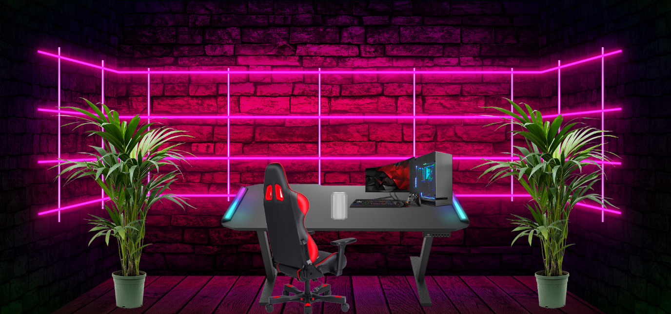

The arrows and circles display the changes made to the mock design graphic.

The new version of the 3D mock feels much livelier and more authentic compared to the prior graphic.

# Developing graphics

## 2D Graphic

### 2D Optimisation

## 3D Graphic

Here is a list of all of the assets I have used for this 3D graphic

[Table](https://sketchfab.com/3d-models/gaming-table-2813ff817fb34e3dbfe3608fb98370b5)

### 3D Optimisation

# Evaluation of Graphics

## 2D Evaluation against brief

## 3D Evaluation against brief